**2016 hint**

2016 HINT

On **January 5th, 2016**, [Cicada’s official Twitter account](https://twitter.com/1231507051321) tweeted [a link](https://twitter.com/1231507051321/status/684596461628223488) to [infotomb.com/4gq25.jpg](https://t.co/LxS3RDz2AC?amp=1) . This link no longer works, as Infotomb is now non-functional. This link led to the following image:

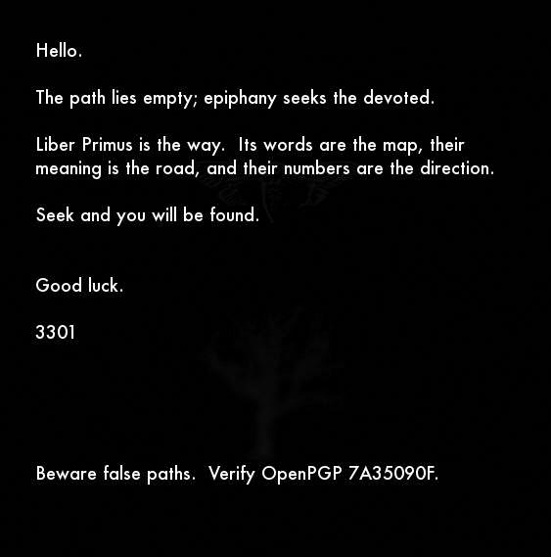4gq25.jpg

The apparent purpose of this image, [*4gq25.jpg*](https://www.3301archive.com/4gq25-jpg/) , seems to be to confirm the status of [Liber Primus](https://www.3301archive.com/liber-primus/) as Cicada’s active challenge — as well as to warn against pursuing [the puzzles of imitators](https://www.3301archive.com/fakes/).

**Notes**:

**+** Two figures can be [seen faintly in the background](https://www.3301archive.com/4gq25-jpg-processed/) of *4gq25.jpg* : a cicada and an oak tree — both also found in Liber Primus.  
————

**\*** Given *4gq25.jpg*‘s use of the phrase ‘**epiphany** seeks the devoted’, as well as prior years’ puzzles’ release dates and *4gq25.jpg*‘s release date of **January 5th**, it should be noted that **January 6th** is the traditional date of the Christian holiday ‘[**Epiphany**](https://en.wikipedia.org/wiki/Epiphany_(holiday))‘. This observation has not led to any progress, however.  
  
**\*\*** Cicada’s three annual challenges (2012, 2013, 2014) were released, respectively, on:  
[**January 4th**](https://www.3301archive.com/2012-walkthrough/)**,**[**January 5th**](https://www.3301archive.com/2013-walkthrough/)**, and**[**January 6th**](https://www.3301archive.com/2014-walkthrough/)**.**

**\*\***\* The word ‘**Epiphany**‘ has been used before. In [zN4h51m.jpg](https://www.3301archive.com/zn4h51m-jpg/), the opening image of the 2014 round released on **January 6th, 2014**, the phrase ‘**Epiphany is upon you.**‘ was used.